**TECHNICAL ARCHITECTURE OVERVIEW – EYES SOFTWARE**

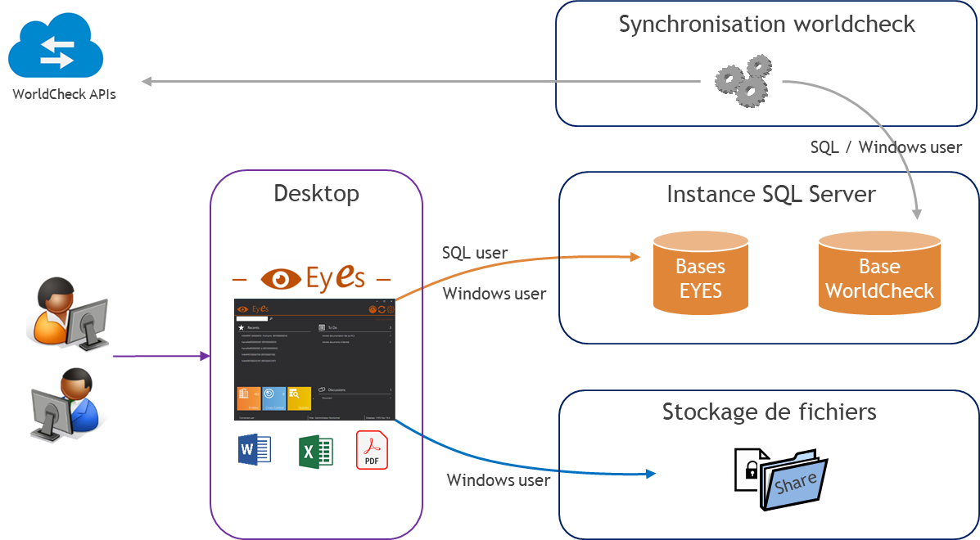

**Client-side prerequisites**

EYES software is a « desktop application » and is deployed on user workstation.

Login is done with an applicative user defined in the EYES database (no SSO/AD authentication at that time).

Microsoft Office tools (Excel, Word) as well as a PDF reader tool must be available.

|  |  |
| --- | --- |
| **Type** | **Version** |
| Operating system | Desktop Windows 7, 10, 11  Server Windows 2019, 2022 |
| Microsoft .Net Framework | 4.8 |
| Minimum memory (RAM) | 2GB |
| Minimum disk space | 250MB |

**Server-side prerequisites**

The server-side functionalities are divided into 3 parts:

* SQL for database hosting.
* File storage.
* Applicative tasks (e.g. WorldCheck sync process).

This split is a functional overview and does not necessarily require 3 separate servers. The client is free to integrate these parts on one or more servers.

* SQL

The SQL instance hosts the various databases (EYES and World-Check) required for the proper functioning of the application.

SQL authentication can support mixed mode (SQL login or Windows integrated).

|  |  |
| --- | --- |
| **Type** | **Version** |
| SQL server Version | 2019 to 2022 |
| SQL server edition | Express Advanced or Standard |
| SQL server Collation | **SQL_Latin1_General_CP1_CI_AS** |
| SQL server Feature | **Full Text Search** |
| Minimum memory (RAM) | 8GB |
| Minimum disk space | 20GB |

* File storage

Disk space for files will need to be allocated. These files are accessed and managed from the EYES app through the user's Windows account.

|  |  |
| --- | --- |
| **Type** | **Version** |
| Minimum disk space | 15GB |

* Applicative tasks

The synchronization tool is an executable, launched at regular intervals using Windows tasks. It retrieves data from World-Check (in CSV format) and then injects it into a dedicated database.

World-Check provides an API queried through an HTTPS request with user/password.

|  |  |
| --- | --- |
| **Type** | **Version** |
| Microsoft .Net Framework | 4.8 |
| Minimum Memory (RAM) | 2GB |
| Minimum disk space | 5GB |